Name: KANMANI K B
Reg No:192524306

Experiment-1
Date: 06.08.2026
CREATE A SIMPLE CLOUD SOFTWARE APPLICATION AND PROVIDE IT AS A SERVICE USING ANY CLOUD SERVICE PROVIDER TODEMONSTRATE SOFTWARE AS A SERVICE (SAAS).
Aim:
To develop simple cloud software application and provide it as a service using any cloud service provider to demonstrate software as a service (saas).
Procedure
- Open a web browser.
- Visit https://creator.zoho.com.
- Sign up using an email ID or Google account.
- Log in to the Zoho Creator dashboard.
- Click Create New Application.
- Select From Scratch.
- Enter the application name.
  - Example: Product Selling System
- Click Create.
- Click Create → Form.
- Name the form Product Details.
Implementation:
if(charging_type == "fast_charging")
{
input.bill_amount = input.charged_required * 20;
}
else
{
input.bill_amount = input.charged_required * 15;
}

Output:
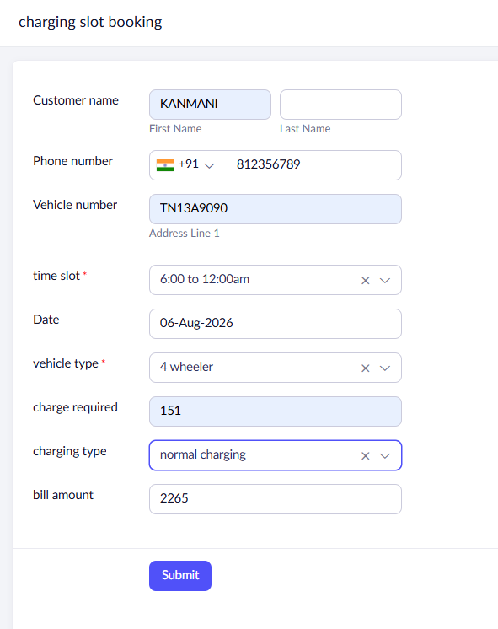
Sample Screenshots:

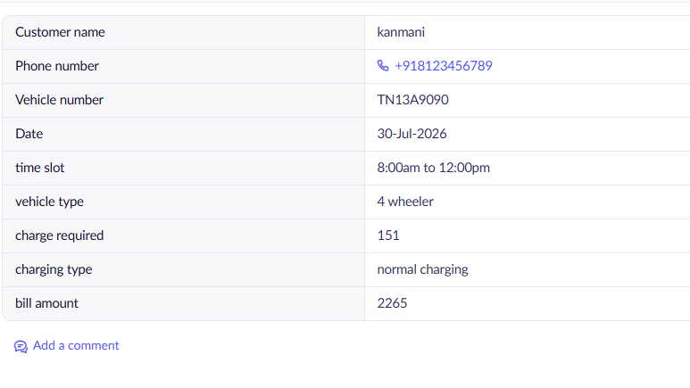

Result
A cloud-based Product Selling Application was successfully created using Zoho Creator and deployed as a Software as a Service (SaaS) application. The application allows users to enter product details, automatically calculates the total amount, stores the records in the cloud, and can be accessed through a web browser from anywhere with Internet connectivity.

